RTOS Mini Project

Smart Home System using RTOS Concepts (Simulated Sensors)

S.No | Name | Registeration Number | Branch
1 | Adithya Rao Kalathur | 251100610012 | CSE
2 | Ashirvad B M | 251100610024 | CSE
3 | Harish Kumar D | 251100610006 | CSE

Objective
To simulate a smart home environment controlled by an embedded RTOS, demonstrating key RTOS features such as:
- Periodic Tasks
- Semaphores (with timeouts)
- Message Boxes (with timeouts)
- Mutex with Priority Inheritance
- Priority Ceiling Protocols (ICPP and OCPP simulations)
- Event Flags and Task Communication

Platform
- Microcontroller: LPC2378 (ARM7TDMI-S Core)
- RTOS: Keil RTX (CMSIS-RTOS style, via <RTL.h>)
- IDE: Keil µVision
- Peripherals Simulated:
  - Temperature Sensor
  - Light Sensor
  - Motion Detector
  - LCD Display
  - LEDs for fan/light indicators

System Description
The project emulates a Smart Home Controller that monitors and reacts to:
- Temperature: Controls fan speed (via LEDs).
- Light Level: Adjusts room lighting (via LEDs).
- Motion: Overrides light control temporarily for safety/visibility.
- Clock: Blinks periodically as a system heartbeat.
- Logger: Displays recent system actions.
- Emergency Monitor: Alerts in case of overheating.
Each module is implemented as a separate RTOS task, coordinated through synchronization primitives.

Hardware / Software Components Used

Component | Type | Purpose
LPC2378 MCU | Hardware | Main processing core with GPIO for LED/LCD
LEDs (P2.0–P2.7) | Hardware | Indicate system states (fan, light, clock)
LCD (16x2) | Hardware | Display system information and logs
Keil RTX (RTOS) | Software | Manages multitasking and synchronization
Semaphores | Software | Protect shared sensor data
Mutexes | Software | Protect LCD and ceiling manager
Message Box | Software | Queue for log messages
Timers/Delays | Software | Used to simulate real-time behavior

System Architecture
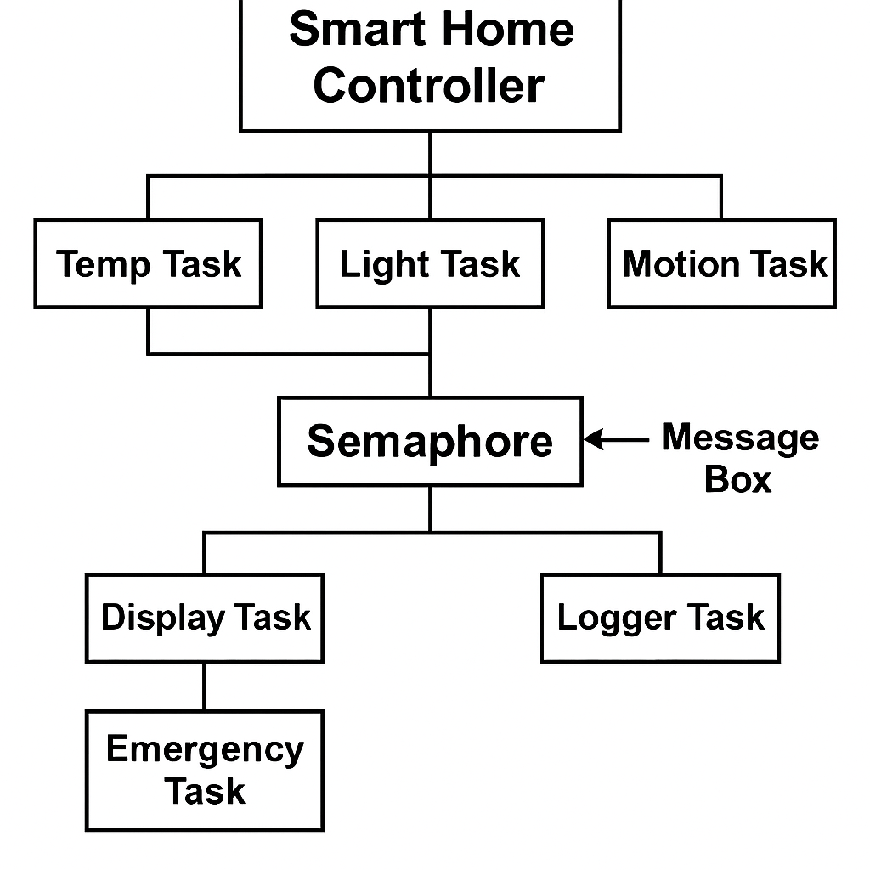

Task Summary
Task Name | Function | Priority | Key RTOS Features Used
temp_task | Simulates temperature & controls fan LEDs | 3 | Semaphore, ICPP, MessageBox
light_task | Simulates light level & controls lighting LEDs | 4 | Semaphore, OCPP, Event Flags
motion_task | Simulates motion detection events | 2 | Event flags
display_task | Displays live readings on LCD | 5 | Semaphore, Mutex
logger_task | Displays recent log on LCD | 6 | MessageBox, Mutex
emergency_task | Detects overheating & flashes LEDs | 1 | Mutex
clock_task | LED heartbeat for system activity | 7 | Delay (Periodic task)

RTOS Concepts Demonstrated
Periodic Tasks
All tasks in this demo are periodic.
They perform actions, delay for a defined period, and repeat.
Task | Mechanism
temp_task() | os_dly_wait(200); — every 200 ticks
light_task() | os_dly_wait(50); — faster updates
motion_task() | os_dly_wait(800); — detects motion periodically
clock_task() | os_dly_wait(5/95); — blinking heartbeat
emergency_task() | os_dly_wait(50); — checks overheating regularly

Semaphore with Timeout
Used for protecting shared sensor data between multiple tasks.
if (os_sem_wait(&sem_sensors, 50) == OS_R_OK) {
sensor_temp = temp;
os_sem_send(&sem_sensors);
}
- Used In: temp_task(), light_task(), display_task()
- Timeout: 50 ticks (prevents deadlock)
- Purpose: Avoids race conditions while updating sensor_temp and sensor_light.

Message Box with Timeout
Used to log system activities asynchronously.
os_mbx_send(&msgbox, (void*)log_pool[idx], 40);
os_mbx_wait(&msgbox, &msg, 120);
- Used In:
  - temp_task() → sends temperature logs
  - light_task() → sends light logs
  - logger_task() → waits and displays logs
- Timeouts:
  - Send: 40 ticks
  - Receive: 120 ticks
This allows producer-consumer synchronization between tasks.

Mutex with Priority Inheritance
Protects the LCD display from concurrent access.
if (os_mut_wait(&mut_lcd, 100) == OS_R_OK) {
LCD_puts((U8*)line);
os_mut_release(&mut_lcd);
}
- Used In: display_task(), logger_task(), emergency_task()
- RTOS Feature: If a low-priority task holds the mutex, a higher-priority waiting task inherits its priority temporarily to prevent priority inversion.

Priority Ceiling – ICPP Simulation
Immediate Ceiling Priority Protocol simulated via icpp_acquire() and icpp_release() functions.
while (!icpp_acquire(self)) os_dly_wait(5);
update_temp_leds(level);
icpp_release(self);
- Used In: temp_task()
- Concept: When a task acquires a resource (like LEDs), no other task can preempt it until it releases the resource.
- Simulation: Uses global ceiling_owner variable.
Variable | Role
ceiling_owner | Tracks which task holds the resource
mut_ceiling | Protects access to ceiling variables

Priority Ceiling – OCPP Simulation

Original Ceiling Priority Protocol simulated via ocpp_acquire() / ocpp_release().
if (ocpp_acquire(self, LIGHT_RESOURCE_CEILING)) {
update_light_leds(level);
ocpp_release(self, LIGHT_RESOURCE_CEILING);
}
- Used In: light_task()
- Resource Ceiling: LIGHT_RESOURCE_CEILING = 2
- Concept:
  - Task can acquire resource only if its base priority ≤ ceiling.
  - Prevents low-priority tasks from blocking higher ones indirectly.
- Simulation Variables:
  - system_ceiling (global ceiling state)
  - task_table[] (records task base priorities)

Tables of Synchronization and Communication
Semaphore Usage
Semaphore | Protected Resource | Used By Tasks | Timeout
sem_sensors | Shared sensors (temp, light, motion) | temp_task, light_task, display_task | 50 ticks

Mutex Usage
Mutex | Protected Resource | Tasks Using It | Purpose
mut_lcd | LCD display | display_task, logger_task, emergency_task | Avoid concurrent LCD access
mut_ceiling | ICPP/OCPP state | temp_task, light_task | Protects ceiling manager variables

Message Box
Message Box | Size | Producer Tasks | Consumer Task
msgbox | 5 | temp_task, light_task | logger_task

Event Flags
Flag | Meaning | Sender | Receiver
EVT_TEMP_UPDATE | Temperature update | temp_task | display_task
EVT_LIGHT_UPDATE | Light update | light_task | display_task
EVT_MOTION | Motion detected | motion_task | light_task, display_task

System Behavior Summary
Condition | Action Taken
Temperature rises above threshold | Fan LEDs increase gradually
Room becomes dark | Light LEDs increase
Motion detected | All LEDs flash (safety override)
Temperature > 45°C | Emergency task triggers LCD alert and flashing LEDs
System idle | Clock LED blinks periodically

Example LCD Output
Smart Home System
T:30C L:45 M:1
Log:Temp:30C Fan:2
Possible Enhancements
- Add real sensor interface via ADC instead of simulation.
- Implement true priority ceiling protocol using actual os_tsk_prio() API calls.
- Add UART logging or SD card data storage.
- Introduce network control (e.g., MQTT or Wi-Fi).
Result Outputs:
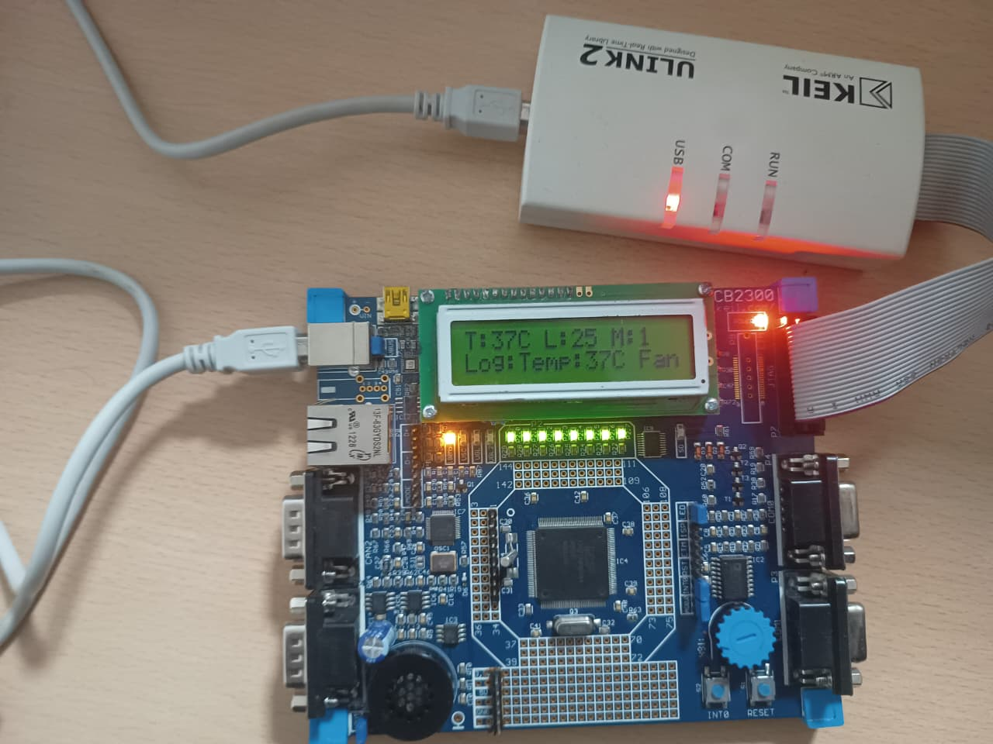

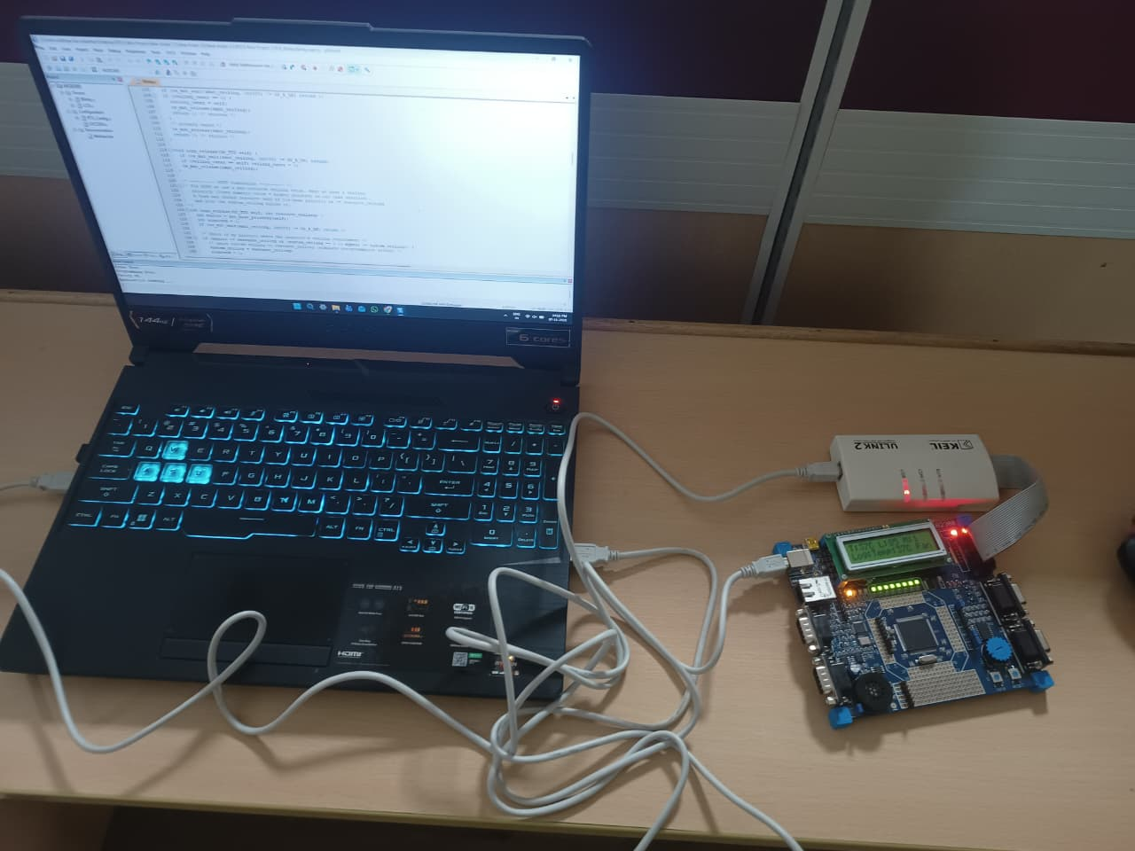

Conclusion
This project effectively demonstrates multiple RTOS synchronization mechanisms in a cohesive smart home simulation.
It showcases:
- Controlled concurrency
- Safe inter-task communication
- Prevention of race conditions
- Handling of real-time constraints
It provides a practical educational platform for understanding how advanced scheduling protocols like ICPP and OCPP can be implemented and observed in embedded systems.

